**STEP FUNCTION**

A step function is a way to moel our workflow a s state machines(one per workflow)

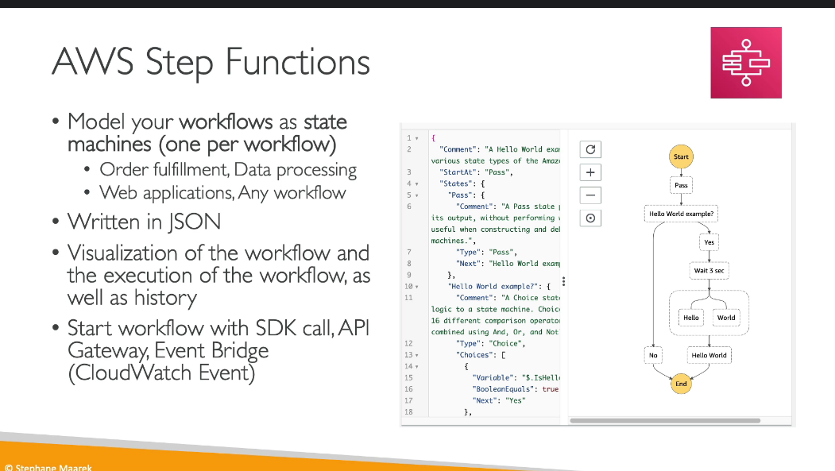

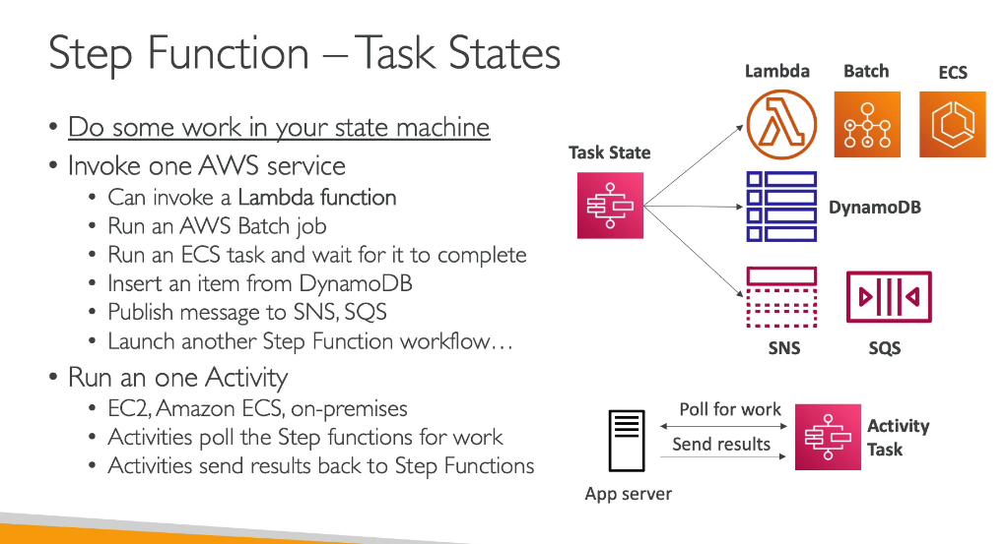

ERROR HANDLING

